a) List all the courses offered by B.Tech CSE program

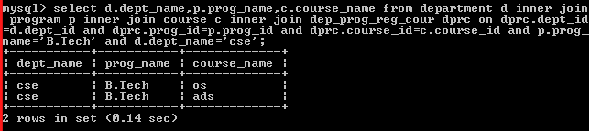

b) List all the programs offered by CSE department.

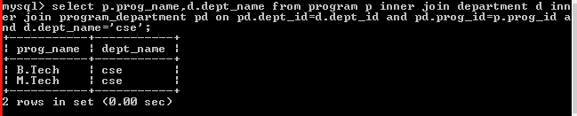

c) List the courses with LTP=202 and regulation is Y14.

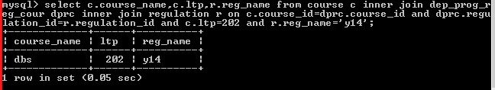

d) List all the students registered to each course of each program.

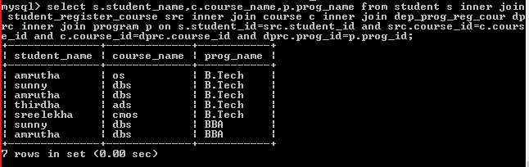

e) List all the students registered to a faculty of a course ‘DBS’ taught by ‘Gaurav’

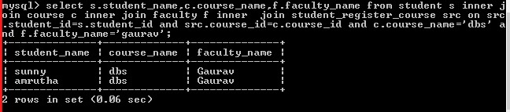

f)List all the faculty teaching M.Tech CNS programme

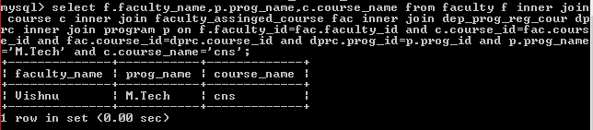

g)List all course name along with its type and the department name for each program under Y12 regulations.

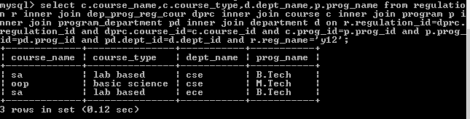

j) List all the elective courses offered by B.Tech ECE program under Y13 regulation.

